**Lab 10 – Normalization 2**

Abcedi Ilacas

138180211

DBS211 NBB

ailacas1@myseneca.ca

**Lab 10 Submission from this page:**

**Question 1**

**For the following User View, determine the 1, 2 and 3NF The UNF relation has been provided.**

**Premiere Corporation**

**Order Detail Report**

|  |  |  |  |  |  |  |  |
| --- | --- | --- | --- | --- | --- | --- | --- |
| **Order Number** | **Order Date** | **Cust Number** | **Cust Last Name** | **Part Number** | **Part Desc** | **Qnty Ordered** | **Quoted Price** |
| 12489 | 2016-09-02 124 | 124 | Adams | AX12 | Iron | 11 | 14.95 |
| 12491 | 2016-09-02 311 | 311 | Charles | BT04 | GasGrill | 3 | 440.00 |
| BZ66 | Washer | 1 | 399.99 |
| CX11 | MiniBlender | 1 | 11.98 |
| 12494 | 2016-09-04 | 315 | Daniels | CB03 | Bike | 4 | 279.96 |
| 12495 | 2016-09-04 | 256 | Samuels | CX11 | MiniBlender | 2 | 23.96 |
| 12498 | 2016-09-05 | 522 | Nelson | AZ52 | Dartboard | 2 | 12.96 |
| BA74 | Basketbal | 4 | 24.96 |
| 12500 | 2016-09-05 | 124 | Adams | BT04 | GasGrill | 1 | 149.99 |
| 12504 | 2016-09-05 | 522 | Nelson | CZ81 | Treadmill | 2 | 325.98 |

**UNF:**

**Order** [PKOrderNo, Orderdate, CustNo, CustLname, (PartNo, PartDesc, QtyOrd, Price)]

**1NF:**

Order [PK OrderNo, OrderDate, FK CustNo]

OrderLine [PK (OrderNo, PartNo), PartDesc, QtyOrd, QuotedPrice]

Customer [PK CustNo, CustLName]

**2NF:**

Order [PK OrderNo, OrderDate, FK CustNo]

OrderLine [PK (OrderNo, PartNo), PartDesc, QtyOrd, QuotedPrice]

Customer [PK CustNo, CustLName]

**3NF:**

Order [PK OrderNo, OrderDate, FK CustNo]

OrderLine [PK (OrderNo, PartNo), PartDesc, QtyOrd, QuotedPrice]

Customer [PK CustNo, FK RepNo]

Rep [PK RepNo, RepName]

**Question 2**

**For the following User View, determine the UNF, 1, 2 and 3NF**

**Movie rental report**

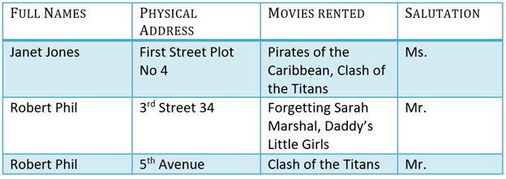

**UNF:**

Rental [FullName, PhysicalAddress, (MoviesRented), Salutation]

**1NF:**

Customer [PK (FullName, PhysicalAddress), Salutation]

Rental [PK (FullName, PhysicalAddress, MovieTitle)]

**2NF:**

Customer [PK (FullName, PhysicalAddress), Salutation]

Rental [PK (FullName, PhysicalAddress, MovieTitle)]

**3NF:**

Customer [PK FullName, FK SalutationId]

Address [PK PhysicalAddress, FK FullName]

Rental [PK (FullName, PhysicalAddress, MovieTitle)]

Salutation [PK SalutationId, Salutation]